Data Definition Language
2520030181
M. Yashwant raj

- CREATE TABLE
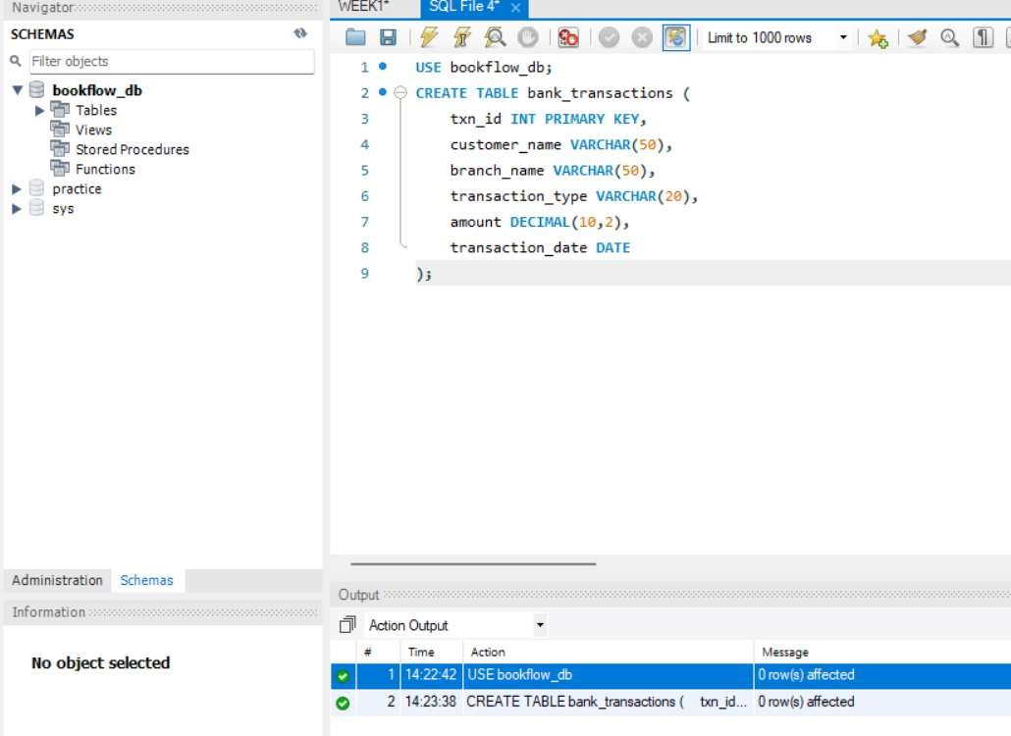
- ALTER TABLE — ADD COLUMN

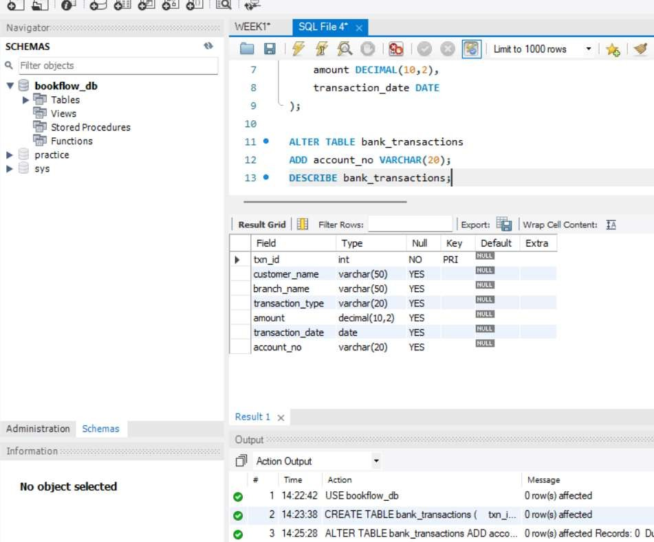
- ALTER TABLE — MODIFY COLUMN
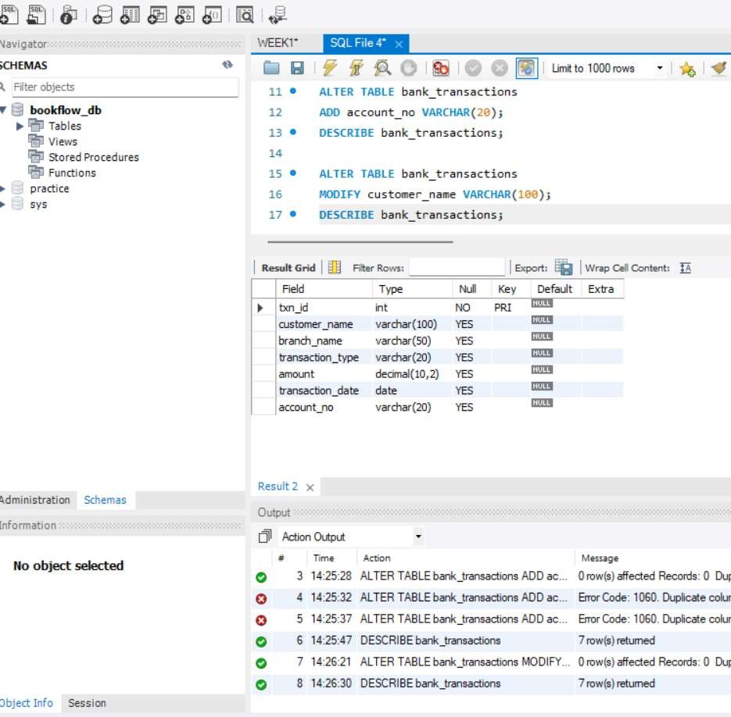
- RENAME TABLE

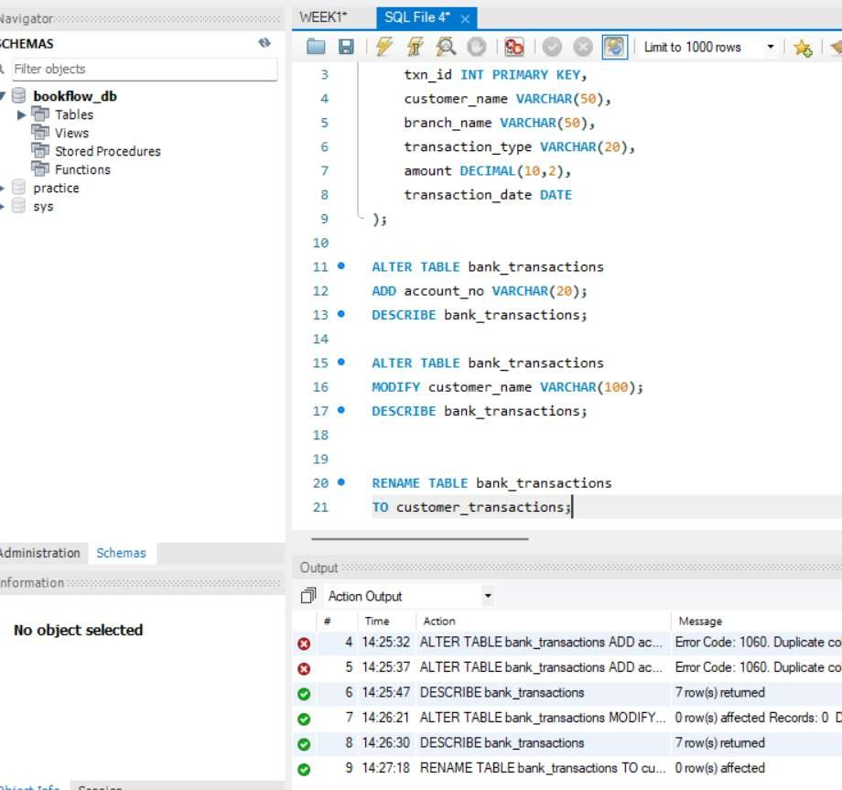
- TRUNCATE TABLE
